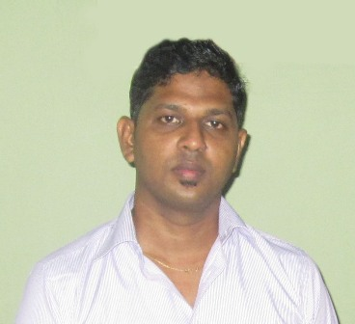

CURRICULUM VITAE
MR.JAYAPRAKASH EDWARD JHONSON
NO:81,SHANTHI ROAD,
HENDALA,WATTALA.
TEL:0752820567 / 0776913174
Email: e.jhon23@yahoo.com/edwardjhon81@gmail.com

PERSONAL DETAILS

- FULL NAME : Mr.Jayaprakash Edward Jhonson
- DATE OF BIRTH : 13.09.1981
- SEX : Male
- HEIGHT : 5.8
- WEIGHT : 72 - 75 kg
- RELIGION : Christian
- RACE : Sri Lankan Tamil
- CIVIL STATUS : Married
- N.I.C NO : 812574540 V
- PASSPORT NO : N4600913
- PRESENT OCCUPATION : Printing Minder (offset)

EDUCATIONAL QUALIFICATIONS : C/Blofendal govt vidyalaya col-14
(1987-1998) I have got through the G.C.E.O/L exam
- Religion D 75 – 100 ( mark’s )
- English C 50 – 75 “
- Tamil C “ - “ “
- Social studies S 15 – 40 “
- Mathematics S “ - “ “
- Commerce S “ - “ “
- Science S “ - “ “
OTHER QUALIFICATIONS :
- COMPUTER -; study’s of Office Excel, Office Word, software installing, hardware (windows XP 2000, 2005, 2007, 2010 )
- Well understand over domestic wiring and electrical
- Having ability to ride light vehicles and forkliftwith two year’s experience ( haven’t license for forklift)
PROFESSIONAL QUALIFICATIONS
- I Worked as a mechanical assistant for 3 years at CINTEX TEXTILE (PVT) LTD
- I Have experience working as a as a supervisor for one and half year at EDNA (PVT) LTD
- Thereafter I worked in Printing field for one year.
- Also I worked as a stores helper at BYOD SL (PVT) LTD and promoted as a stores assistant with the passage of time as having enough recommendation for the post by the management, 3years.
- I worked for two years at Sultanate of OMAN sealing cutting to SUPER PLASTICE INDASTRIT. Muscat to Sultanate of OMAN
- I worked as a printing minder at Sri Lanka Shaan Traders (Pvt) Ltd last 5 years
- At present I am working as a PRINTING MINDER since July 2014 at Wilkins Spence Packaging Lanka ( Pvt) Ltd

I was overall in-charge of and responsible for the following areas of activities.
Over looking all the stores functions. Sending condition reports to the management based on the quality of the material. Sending proposals for the idle/overdue stocks. Inform arrival status of the products to the sales departments
Stores documentation 3year’s
- Bin cards
- Issues
- Receives
- Purchase returns
- Other stores trivial documents
- Flexibility of working in a fully data and computerized environment

Experience of Printing 5year’s
- Paper cutting ( Chains cutter )
- Die cutting ( off set cylinder )
- Matt & Gloss Laminating
- Plate Exposing
- Book Binding
- And offset Printing ( German koerd )

Languages,
Tamil, Sinhala, English, Hindi, Malayalam, Arabic

Non related referees
Mr.M.F.R.B. Julian Mr. S. Ravindran
Wharf Executive Store keeper
Gateway Agency ( pvt ) Ltd Royalty
No; 44 Lotus Road, No; 50, Kelanigaga Road,
Colombo - 01 Mattakuliy
Phone ; 077 4237262 Colombo-15
Tp-077 2920133
Offices ; 0112 527296

I CONFRM THAT THE ABOVE INFORMATION GIVEN IS ACCURATE
05.12.2014 
……………………………………………… ……………………………………………
DATE SIGNATURE.

